September 07, 2017

D E C L A R A T I O N
of the
Dailyurbano.com

- HOME SLIDER

For Home slide we need to login as Admin then there is a option in dashboard named home slider
That has two options 1. Home slider from where you can see all slides that you created before and 2.
add new home slider .from there you can create new slider.

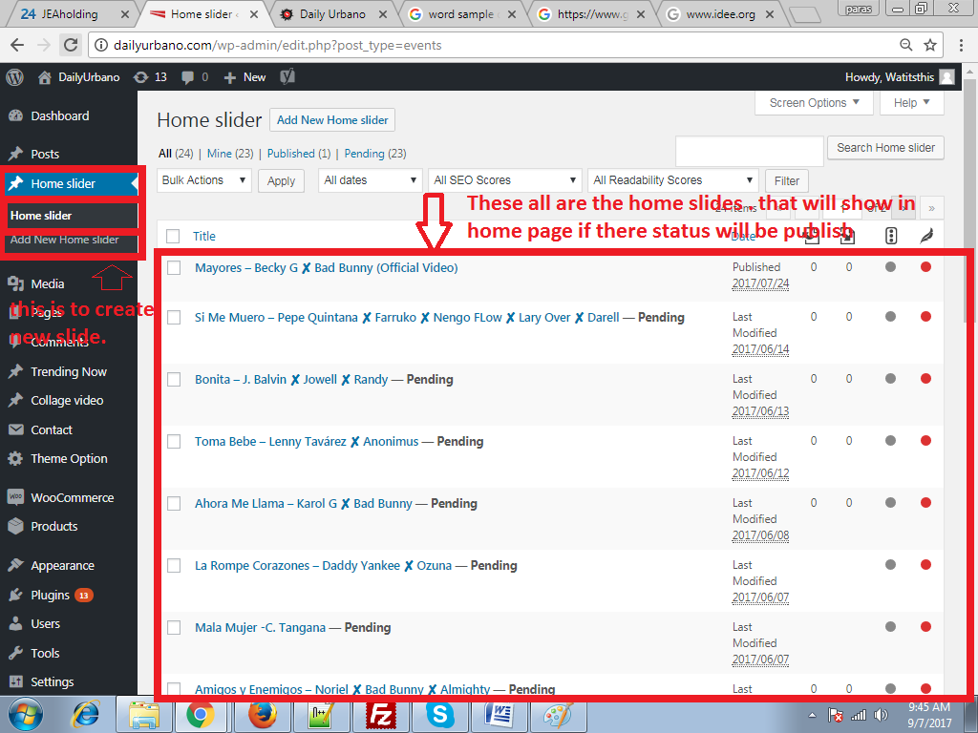

- SCHEDULE VIDEOS

When you create any video from admin side there is a option to schedule the video publish date. When you open any video post then there is a option to publish the post and there is a option to edit publish on time. from there you can set future time to publish post.

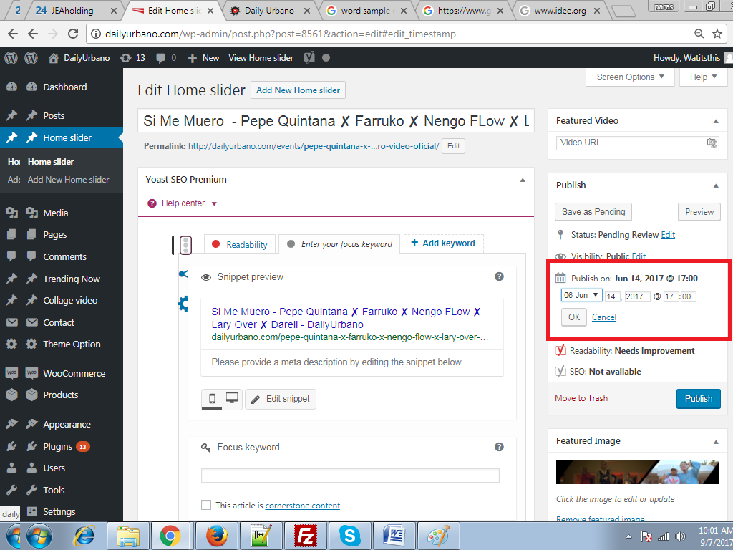

- TRENDING VIDEOS

Trending videos are also same like the home slider there is a option in admin panel for named trending now
From there you can add new trending videos or view already created videos.

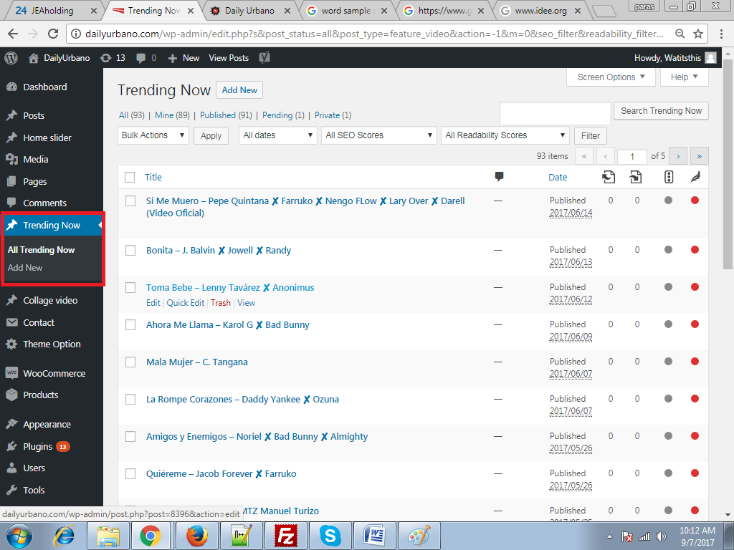

- FEATURED POSTS AND SUB FEATURED POSTS

You can add featured and sub featured posts from trending now section in admin panel
When you create a post you can schedule that post from that page same as
SCHEDULE VIDEOS point 2 from there after that you have to add that post to the featurd video from theme option then it will display on frontend at the scheduled time.

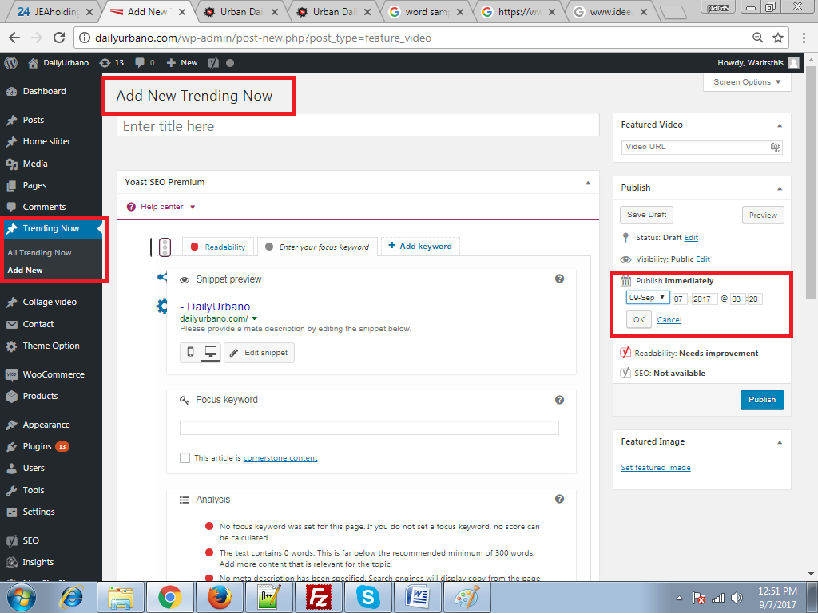

On admin dashboard there is a option to name Theme Option. After that there is a option named
HOME PAGE SETTING from there you can select the video that you have scheduled .
After that you just have to save the page .and you video will be automatically display at frontend
On the given date.

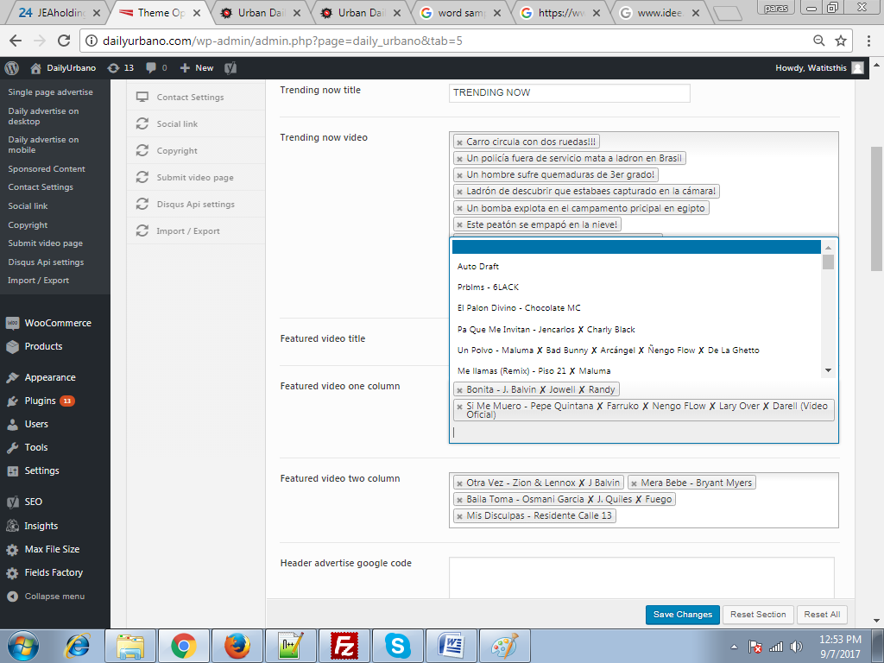

5. ADVERTISEMENTS

From the same home page setting page you can manage you advertisements also you can select left right advertisement.

